

**JOMO KENYATTA UNIVERSITY OF AGRICULTURE AND**

**TECHNOLOGY**

**SCHOOL OF COMPUTING AND INFORMATION**

**TECHNOLOGY**

**BSC. INFORMATION TECHNOLOGY**

**PROJECT TITLE: AI-DRIVEN INJURY AND SCAR DETECTION WITH SIZE ESTIMATION FOR OPTIMAL GAUZE AND BANDAGE ALLOCATION FOR ENHANCED WOUND CARE MANAGEMENT**

**REGISTRATION: SCT221-C004-0151/2022**

**STUDENT NAME: VICTOR MONDERU MWANGI**

This project has been submitted in partial fulfillment of the requirements for the award of the

degree of Bachelor of Science in Information Technology in the year 2025.

# **DECLARATION**

I affirm that the content and information presented in this document and program are entirely my

own. In the event that there is any borrowed information or content, I have duly provided proper

references.

Sign _______________________________ Date ____________________________

Student’s Name: Victor Monderu

Approved by:

Sign_____________________________ Date ____________________________

**Supervisor’s Name:** Dr. Judy Gateri

# **ACKNOWLEDGEMENT**

I express my heartfelt gratitude to everyone who played a role in the successful completion of

this project. Their unwavering support has been invaluable, guiding me from the project's

conception through to its implementation.

I am particularly grateful to my supervisor, Dr. Judy Gateri, whose guidance and insistence on

adhering to due diligence and proper processes have been crucial in navigating this project. Her

commitment to precision has been instrumental in avoiding potential errors and ensuring the

project's success.

Lastly, I extend my appreciation to my parents, friends, and classmates who have accompanied

me on this academic journey. Their encouragement has been a source of strength throughout my

time in college.

# **DEDICATION**

I dedicate this project to the relentless pursuit of knowledge and the unwavering spirit of

curiosity that fuels the journey of discovery. This endeavor is dedicated to those who believe in

the power of learning and the transformative potential it holds.

In heartfelt appreciation, I dedicate this project to my supervisor, Dr. Judy Gateri, whose

guidance has been a beacon of wisdom and support throughout the entire process. Her

commitment to excellence has inspired me to strive for the highest standards in every aspect of

this undertaking.

Furthermore, I dedicate this project to my parents, whose boundless encouragement and

unwavering belief in my abilities have been a constant source of motivation. To my friends and

classmates, thank you for the camaraderie, shared experiences, and the collective strength that

comes from learning together.

May this project stand as a testament to the collaborative spirit of those who value education,

curiosity, and the pursuit of knowledge

# **ABSTRACT**

Wound detection and segmentation is a crucial factor when it comes to medical imaging. The project aims to provide measurements of the wounds in order to provide ease to medical practitioners who will use the given measurements to allocate bandages and gauze of appropriate

calibrated measurements .In doing so the health care practitioners can minimize wastage of the crucial material and track the healing of the patients wound.

This project presents an AI-driven framework for automated injury and scar detection with real-world size estimation to enhance wound care management through optimal gauze and bandage allocation. The system integrates Mask R-CNN for accurate segmentation of wound regions and MiDaS-based monocular depth estimation to convert pixel-based measurements into clinically meaningful units (millimetres). Preprocessing techniques such as image normalization, resizing, and data augmentation were applied to improve model robustness and generalization. Post-segmentation, the system computes key metrics including wound area, perimeter, and maximum width and height by combining depth maps with segmentation masks. Evaluation using Dice Coefficient and Intersection-over-Union (IoU) confirms the system’s accuracy in delineating complex wound boundaries. The framework was implemented using TensorFlow in a GPU-accelerated environment via Google Colab, ensuring computational efficiency and reproducibility.

This project demonstrates the potential of combining deep learning and depth estimation to deliver scalable, accurate, and objective wound assessment, with practical implications for reducing clinical workload, improving patient outcomes, and optimizing dressing material usage in both hospital and remote settings.

This project set the ground work for future improvements, such as deploying the system to the cloud and use of smart wound healing patch to integrate with sensors and drug delivery systems for monitoring the healing process and participate in the healing process.

**LIST OF FIGURES**

Table of Contents

**DECLARATION** ii

**ACKNOWLEDGEMENT** iii

**DEDICATION** iv

**ABSTRACT** v

**CHAPTER ONE: INTRODUCTION** 1

**1.1 INTRODUCTION** 1

**1.2 PROBLEM STATEMENT** 1

**1.3 RESEARCH QUESTIONS** 2

**1.4 OBJECTIVES** 2

**1.4.1 General Objective** 2

**1.4.2 Specific Objectives** 2

**1.5 JUSTIFICATION** 2

**1.6 APPLICATION** 3

**1.7 SCOPE** 3

**1.8 LIMITATIONS** 3

**CHAPTER 2: LITERATURE REVIEW** 4

**2.1 INTRODUCTION** 4

**2.2 Literature Review** 5

**2.2.1 History of wound care** 6

**2.2.2 Current solutions to estimate wound size** 7

**2.2.3 Classification of existing skin lesion calculation methods** 8

**2.2.4 Devices, and software-based computerized methods** 9

**2.3 Theoretical Framework** 14

**2.3.1 Deep Learning Framework:** 14

**2.3.2 Medical Imaging Analysis Framework** 20

**The role of image analysis in medical healthcare** 20

**2.4 Methodology Used in Previous Studies** 21

**ROI detection and area measurement** 23

**Tissue classification** 24

**2.4.1 You Only Look Once(YOLO)** 25

**2.4.2 U-Net** 26

**2.5 Synthesis and Analysis:** 26

**2.6 Gaps in the Literature:** 30

**2.7 Conclusion:** 31

**CHAPTER 3: METHODOLOGY** 32

**3.1 Introduction** 32

**3.2** **SYSTEM ANALYSIS** 38

**Participants or Sample:** 38

**3.2.2 Data Collection** 38

**3.2.2.1 Data Collection methods** 38

**Interviews:** 39

**Surveys and Questionnaires** 39

**3.1.3 Feasibility Study** 40

**3.1.3.1 Technical Feasibility** 40

**3.1.3.1.1 Hardware Analysis** 40

**3.1.3.1.2 Software Analysis** 41

**3.1.3.2 Economic Feasibility** 41

**3.1.3.3 Social Feasibility** 42

**3.1.3.4 Legal Feasibility** 42

**3.1.3.5 Operational Feasibility** 42

**3.2 System Requirement Specification** 43

**3.2.1 Functional Requirements** 43

**3.2.2 Non-functional Requirements** 44

**CHAPTER 4: SYSTEM DESIGN** 45

**4.1 Introduction** 45

**4.2 SYSTEM ARCHITECTURE:** 45

**Use Case Diagram** 47

**4.2.1 Data Flow Representation** 48

**4.2.2 Context Diagram (Level 0 DFD)** 48

**4.3 CONCEPTUAL FRAMEWORK** 49

**CHAPTER 5: IMPLEMENTATION** 51

**5.1 Introduction** 51

**5.2 Tools Used** 51

**5.2.1 Programming Language and Coding Tools** 51

**5.2.2 Frameworks** 52

**5.3 Hardware Specifications** 53

**5.3.1 Personal Computers** 53

**5.3.2 Machine Learning** 54

**5.4 Software Specification** 55

**5.4.1 Operating Systems** 55

**5.5 Testing** 56

**5.5.1 Unit Testing** 57

**5.5.2 Integration Testing** 57

**5.5.2.1 Alpha Testing** 57

**5.5.2.2 Beta Testing** 57

**5.6 SCREENSHOTS OF THE SYSTEM:** 58

**5.7 FUTURE SCOPE** 60

**5.8 CONCLUSION** 60

**CHAPTER 6: CONCLUSION AND FUTURE WORK** 61

**6.1 Conclusion** 61

**6.2. Future Perspectives** 61

**REFERENCES:** 63

# **CHAPTER ONE: INTRODUCTION**

## **1.1 INTRODUCTION**

Wound care is a vital aspect in any healthcare setting in surgical wards and emergency cases. Proper wound care management is a challenge in most healthcare facilities in that the healthcare team have to approximate the correct size of gauzes and bandages just from assessing a wound from an injury .This manual approximation leads to issues such as material wastage due to overuse and inadequate treatment due to underuse .This is a major issue in healthcare facilities with limited resources

Various approaches have been initiated for example the use of simple measurement tools to estimate wound size, while others have developed standardized wound assessment protocols. Despite all this methods depend on manual assessment ,which is time consuming and prone to many errors. Technological advancements in AI and imaging have brought ease to the process, with some organizations experimenting with basic image recognition tools for wound classification. However these does not fully address the issue of optimizing material allocation

This project is being conducted to focus on integrating artificial intelligence to improve clinical workflows and patient outcomes. By taking advantage state-of-the-art AI techniques, we aim to streamline the process of wound detection, classification, measurement, and gauze/bandage allocation. Inclusion of AI in this system will allow precise wound measurement through image analysis, better material selection, and personalized care instructions.

## **1.2 PROBLEM STATEMENT**

In healthcare setting ,the mechanical process of wound assessment leads to discrepancies such as inaccurate measurements and usage or underusage of medical equipment such as gauzes and bandages. Overuse of this medical resources results in material wastage ,strain in medical resources and increased cost of health service while underuse will result to inadequate coverage, which compromises wound healing and increases the risk of infections .Lack of an automated system would exacerbate this issues. Despite efforts to develop guidelines and manual tools for

wound management, these approaches still fall short due to their reliance on human judgment, variability in wound presentation, and a lack of integration with real-time data. This inefficiency is particularly problematic in resource-constrained settings, where healthcare providers need to manage supplies carefully to ensure the best outcomes for all patients.

## **1.3 RESEARCH QUESTIONS**

1. How can AI effectively classify and detect different types of wounds and scars using medical imaging?
2. What AI techniques can be used to accurately measure wound dimensions for gauze and bandage allocation?
3. How can reinforcement learning be applied to optimize material usage in wound care while minimizing wastage?

## **1.4 OBJECTIVES**

### **1.4.1 General Objective**

The general objective of this project is to develop an AI-based system that automates injury detection, wound classification, and material allocation for wound care, thereby reducing medical material wastage and improving treatment efficiency.

### **1.4.2 Specific Objectives**

1. To design and implement a Convolutional Neural Network (CNN) model for the detection and classification of various wound types and scars from medical images.
2. To apply Mask R-CNN for accurate segmentation and measurement of wounds, enabling precise gauze and bandage allocation.
3. To optimize material allocation based on wound size, ensuring the minimal wastage of medical resources.

## **1.5 JUSTIFICATION**

**T**his project is justified by the need for proper wound care management reducing material wastage and enhances accuracy of treatment. The manual method used are prone to errors leading to resource wastage and inefficient patient care. By introducing AI into the wound care process, healthcare providers can make data-driven decisions about material allocation, reducing costs and improving patient outcomes. The proposed AI system will not only enhance efficiency in high-resource settings but also have a transformative impact on resource-limited healthcare facilities, where optimal use of medical supplies is critical for patient survival and care quality.

## **1.6 APPLICATION**

The project is designed to support healthcare practitioners in accurately assessing wounds and optimizing the selection of gauze and bandages for improved wound care management. By automating detection, segmentation, and measurement of injuries from clinical images, this tool enhances clinical efficiency, reduces supply wastage, and supports consistent wound monitoring. Relevant practitioners who will benefit from this system include wound care nurses, emergency room physicians, dermatologists, trauma surgeons, and home healthcare providers, enabling them to make data-informed decisions and deliver more precise, timely, and cost-effective wound treatment.

## **1.7 SCOPE**

The project will be limited to the design and testing of an AI-driven injury detection, classification, and material allocation system. Testing of the system shall then be done in simulated clinical environments using the pre-labelled medical image datasets. In this context, the scope of work will involve the design of CNN for wound classification, a Mask R-CNN for wound segmentation, and reinforcement learning for material optimization.

## **1.8 LIMITATIONS**

1. The accuracy of the system will depend on the quality and diversity of the medical image datasets available for training.
2. Integration into live clinical environments may require additional testing and validation to account for real-time variability in wounds.
3. The system may face deployment challenges in low-resource environments due to limited computational power or lack of infrastructure for real-time AI processing.

# **CHAPTER 2: LITERATURE REVIEW**

## **2.1 INTRODUCTION**

Wound management forms a significant component in health care, especially regarding those patients who have suffered from chronic wounds or specified injuries that require special care and monitoring regularly. Traditional assessment methodologies of the wound heavily rely on ocular observation and subjective analysis by the care provider, often contributing to variability and delaying diagnosis and treatment processes. AI technologies open new avenues toward better approaches for wound care through better speed and precision in the detection of wounds and scars. With computer vision and machine learning, for instance, AI-driven systems will be able to independently assess wounds through the detection of injury patterns, classification of wound types, and monitoring of healing processes. Current research indicates that AI technologies can significantly help in managing wounds, right from the identification of the wound types to the allocation of appropriate materials needed for their care.

For instance, the depth, width, color, and status of tissue around a wound are considered when a computer vision algorithm analyzes an image of the wound for choosing the right type of gauze and bandaging materials. AI integrated into resource management systems can better equip them to distribute gauze, bandages, and dressings to patients and manage the use of such dressings. This might also be interpreted as an improved clinical outcome with better cost allocation within healthcare by minimizing material waste, thus providing quality care in both clinical and remote settings.

This review, therefore, synthesizes current research into AI-driven wound assessment technologies, including their applications in injury and scar detection and optimal resource allocation in the care of wounds. It reviews the current uses of AI in medical imaging, debates benefits and limitations of automated systems in managing wounds, and points to areas where further studies are needed. This review aims to provide an encompassing overview of the positioning of AI in wound care, highlighting the prospect of improving patient outcomes with more accurate, scalable, and personalized wound management solutions.

**2.2 Literature Review**

A wound is defined as any injury to the loss of continuity of the skin or body tissue that disrupts the integrity of the barrier function by rupturing a membrane and damaging the tissue beneath the skin (Kujath et al., 2023). The wound can be caused by physical, thermal, chemical, and radiogenic trauma. When a portion of the skin surface breaks, a wound is created, and wound healing begins to regenerate the integrity of the tissue and restore barrier function. The regenerating cells are guided towards a connective tissue scaffold to form normal, functional tissue structures. Various cell types and signaling molecules are involved in the repair and regeneration of the damaged tissue. For example, stem cells in the surrounding tissue can migrate to the site of the wound and differentiate into various cell types, such as fibroblasts, which produce collagen and other extracellular matrix proteins that contribute to the formation of a scaffold for tissue repair . The classification of wounds is not a universal standard. Wounds are typically classified into categories depending on the cause of the wound, the duration of wound healing, and the depth of the wound. Acute and chronic wounds are traditional terms for healing and non-healing wounds, classified according to the duration of wound healing. An acute wound has a normal healing process that is short and has no complications. The acute wound heals with primary intention and without tissue loss. Examples of acute wound healing include superficial traumatic wounds, first-degree burns, and surgical

wounds. When acute wound healing is interrupted and the proliferation process continues for more than four to six weeks, a chronic wound develops. The chronic wound heals with secondary intention, resulting in a lengthy healing process and complications due to some tissue loss that can affect many biological pathways.

### **2.2.1 History of wound care**

The history of wound healing is, in a sense, the history of humankind. One of the oldest medical manuscripts known to man is a clay tablet that dates back to 2200 BC. This tablet describes, perhaps for the first time, the ‘‘three healing gestures’’—washing the wounds, making the plasters, and bandaging the wound.( Jayesh et al., 2012)

Ancient methods included using natural substances like honey, oil, and herbs to protect wounds and prevent infections. Egyptians pioneered adhesive bandages and honey-based treatments, while Greeks and Romans emphasized cleanliness and noted the four cardinal signs of inflammation.

The history of wound-site dressing has seen significant advancements over the decades. During World War I, Dakin's Solution was developed by Henry Drysdale Dakin to cleanse traumatic wounds effectively. The 1950s introduced fibrous synthetics like nylon and polyethylene, paving the way for innovations in wound protection and healing. By the 1960s, research highlighted the superiority of moist wound dressings, revolutionizing clinical outcomes and establishing modern wound care practices.

The 1990s brought composite and hybrid polymers, enabling the creation of advanced wound dressings such as biologics and skin substitutes, which support healing by facilitating the delivery of essential growth factors. Modern wound care also emphasizes addressing patient pain, particularly for chronic and severe wounds.

In contemporary medicine, wound care involves promoting healing, preventing infections, and selecting appropriate dressings based on wound type. A variety of dressing types are used, including dry dressings, foam dressings, alginate dressings, and hydrocolloid dressings, each tailored to specific needs. Innovations like chemical-impregnated dressings and biologically based products, such as Integra's artificial skin, further enhance the treatment of complex wounds, improving recovery and patient outcomes.

Advances in image processing technology are expected to enable comprehensive monitoring of the wound healing process through detailed analysis of wound images. By leveraging artificial intelligence and deep learning algorithms, the wound image diagnostic system can extract more accurate features, perform diagnostic analysis, and predict wound healing time through big data analysis. Moreover, the integration of wearable devices will enhance wound monitoring by enabling real‐time and continuous data collection, thereby supporting personalized wound management. These mobile medical devices can effectively monitor wound healing, reduce healthcare costs, and allow for remote analysis of wound images by healthcare professionals without the need for frequent hospital visits. Patients can receive expert attention remotely and some devices even offer real‐time wound assessment and diagnosis, empowering patients to stay informed about their own wound healing progress.( Zhao et al., 2024)

### **2.2.2 Current solutions to estimate wound size**

To determine the size of the wound, some professionals use methods such as planimetry, which involves drawing the outline of the wound with trans-parent acetate paper and measuring the surface with a device afterwards. Other methods include more traditional elements, such as rulers or reference markers in photography. However, these methods of area measure are inaccurate methods with a high error rate. There are alternatives on the market that increase the level of accuracy (e.g., stereo cameras, depth cameras, thermal cameras) , but their high costs and difficulty of use by professionals make them challenging to implement in a healthcare system. For this reason, most professionals use methods that simplify the data collection process; for example, using a ruler to measure the two axes of the ellipse containing the wound. However, these simplified methods increase the introduction of accuracy errors.( David Reifs 2023)

To perform tissue classification, there are some studies that have worked on the automatic classification of tissue by means of photography. However, at present, there is no sufficiently widespread mechanism that allows the professional to detect the presence and percentage of necrotic tissue, or the distribution of other tissues in the wound bed. The professional must visually examine the wound and, based on his or her experience, determine whether or not these tissues exist, as well as their predominance. It should be noted that the existence of necrotic tissue will inevitably require specific clinical action to remove it before the treatment can be applied to heal the wound.

To perform tissue classification, there are some studies that have worked on the automatic classification of tissue by means of photography. However, at present, there is no sufficiently widespread mechanism that allows the professional to detect the presence and percentage of necrotic tissue, or the distribution of other tissues in the wound bed. The professional must visually examine the wound and, based on his or her experience, determine whether or not these tissues exist, as well as their predominance. It should be noted that the existence of necrotic tissue will inevitably require specific clinical action to remove it before the treatment can be applied to heal the wound.

### **2.2.3 Classification of existing skin lesion calculation methods**

Most skin lesion measurement methods used today are rudimentary (i.e., the ruler, which leads to measurement errors) or are linked to invasive tech-niques (i.e., manual planimetry with transparent acetate, which can be un-comfortable for patients). Hence, stresses that, for skin lesion measure-ment, ”there is still no clear consensus on which is the best method, which is fast, practical, cheap and simple in routine practice.” Therefore, it should be noted that there is no ”gold standard” method for skin lesion measurement approved by the medical community.

Concerning the literature review on the safety and performance of this type of method, classifies the different methods for measuring skin le-sions into the following three major groups: traditional methods, measuring.

## **2.3 Theoretical Framework**

In the context of medical imaging of wounds will revolve around the principles of deep learning, medical imaging analysis and image segmentation. These theories collectively provide the foundation for designing and implementing the AI-driven injury and scar detection system, as well as optimizing gauze and bandage allocation for enhanced wound care management.

### **2.3.1 Deep Learning Framework:**

Deep learning is a branch of machine learning that employs artificial neural networks comprising multiple layers to acquire and discern intricate patterns from extensive datasets. It has brought about a revolution in various domains, including computer vision, natural language processing, and speech recognition, among other areas. Over the years, deep learning advances in computer vision have attracted the attention of many scholars in the field of medical imaging (Vishwakarma et al., 2020). One of the primary advantages of deep learning is its capacity to automatically learn features from raw data, thereby eliminating the necessity for manual feature engineering. This makes it especially powerful in domains with large, complex datasets, where traditional machine learning methods may struggle to capture the underlying patterns. Deep learning has also facilitated significant advancements in various tasks, including but not limited to image and speech recognition, comprehension of natural language, and the development of autonomous driving capabilities. For instance, deep learning has enabled the creation of exceptionally precise computer vision systems capable of identifying objects in images and videos with unparalleled precision. Likewise, deep learning has brought about substantial enhancements in natural language processing, leading to the development of models capable of comprehending and generating language that resembles human-like expression. Overall, deep learning has opened up new opportunities for solving complex problems and has the potential to transform many industries, including healthcare, finance, transportation, and more.( Li, M., Jiang et al., 2023)

As the network learns, the weights on the connections between the nodes are adjusted so that the network can better classify the data. This process is called training, and it can be done using a variety of techniques, such as supervised learning, unsupervised learning, and reinforcement learning. Once a neural network has been trained, it can be used to make predictions with new data it’s received.

### **2.3.1.1 Convolutional Neural Networks:**

A convolutional neural network (CNN) is a deep learning model that uses a network architecture to learn patterns in data and make predictions. CNNs are a type of artificial neural network that are often used for image recognition and processing. A convolutional neural network (Li et al., 2021), known for local connectivity of neurons, weight sharing, and down-sampling, is a deep feed-forward multilayered hierarchical network inspired by the receptive field mechanism in biology. Researchers have successfully applied CNNs for many medical image understanding applications like detection of Wound images. One trend in wound segmentation is the use of CNNs, which have proven to be effective at quickly and accurately processing image data and classifying different wound tissues, such as the epithelialization area, granulation tissue, and necrotic tissue. CNNs have been found quite effective for many computer vision tasks in recent years. They act as trainable image filters which can be used to convolve over images sequentially to measure responses or activations of the input image, creating feature maps. These feature maps are then stacked together, passed through non-linear functions, and further convolved with more filters. This convolution process has been found to be effective at extracting visual features or patterns in images that can be useful for tasks such as classification, segmentation, and super resolution. (Chairat et al., 2023)

Convolutional neural networks are distinguished from other neural networks by their superior performance with image, speech or audio signal inputs. They have three main types of layers, which are:

* Convolutional layer
* Pooling layer
* Fully-connected (FC) layer

The convolutional layer is the first layer of a convolutional network. While convolutional layers can be followed by additional convolutional layers or pooling layers, the fully-connected layer is the final layer. With each layer, the CNN increases in its complexity, identifying greater portions of the image. Earlier layers focus on simple features, such as colors and edges. As the image data progresses through the layers of the CNN, it starts to recognize larger elements or shapes of the object until it finally identifies the intended object.

**Convolutional layer**

The convolutional layer is the core building block of a CNN, and it is where the majority of computation occurs. It requires a few components, which are input data, a filter and a feature map. Let’s assume that the input will be a color image, which is made up of a matrix of pixels in 3D. This means that the input will have three dimensions—a height, width and depth—which correspond to RGB in an image. We also have a feature detector, also known as a kernel or a filter, which will move across the receptive fields of the image, checking if the feature is present. This process is known as a convolution.

The feature detector is a two-dimensional (2-D) array of weights, which represents part of the image. While they can vary in size, the filter size is typically a 3x3 matrix; this also determines the size of the receptive field. The filter is then applied to an area of the image, and a dot product is calculated between the input pixels and the filter. This dot product is then fed into an output array. Afterwards, the filter shifts by a stride, repeating the process until the kernel has swept across the entire image. The final output from the series of dot products from the input and the filter is known as a feature map, activation map or a convolved feature.

Note that the weights in the feature detector remain fixed as it moves across the image, which is also known as parameter sharing. Some parameters such as the weight values, adjust during training through the process of backpropagation and gradient descent. However, there are three hyperparameters which affect the volume size of the output that need to be set before the training of the neural network begins. These include:

1. The**number of filters**affects the depth of the output. For example, three distinct filters would yield three different feature maps, creating a depth of three.

2. **Stride** is the distance, or number of pixels, that the kernel moves over the input matrix. While stride values of two or greater is rare, a larger stride yields a smaller output.

3. **Zero-padding** is usually used when the filters do not fit the input image. This sets all elements that fall outside of the input matrix to zero, producing a larger or equally sized output. There are three types of padding:

* **Valid padding:** This is also known as no padding. In this case, the last convolution is dropped if dimensions do not align.
* **Same padding:** This padding ensures that the output layer has the same size as the input layer.
* **Full padding:**This type of padding increases the size of the output by adding zeros to the border of the input.

After each convolution operation, a CNN applies a Rectified Linear Unit (ReLU) transformation to the feature map, introducing nonlinearity to the model.

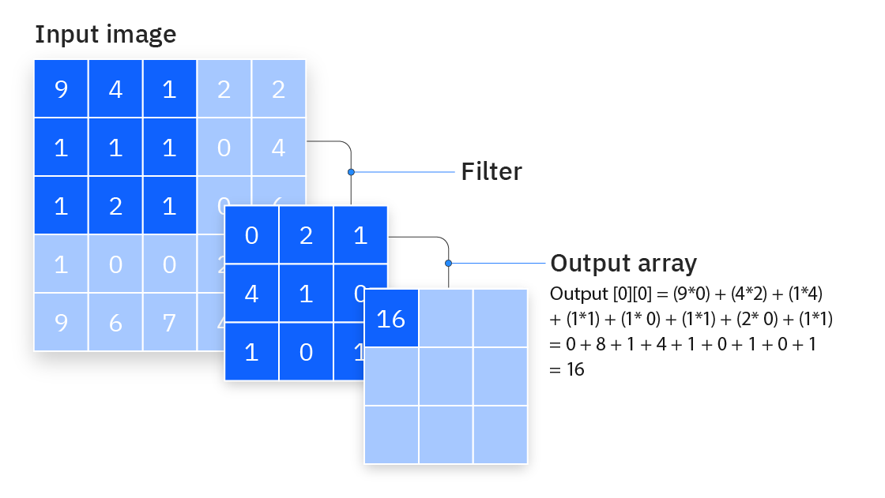

**Additional convolutional layer**

As we mentioned earlier, another convolution layer can follow the initial convolution layer. When this happens, the structure of the CNN can become hierarchical as the later layers can see the pixels within the receptive fields of prior layers. As an example, let’s assume that we’re trying to determine if an image contains a bicycle. You can think of the bicycle as a sum of parts. It is comprised of a frame, handlebars, wheels, pedals, and so on. Each individual part of the bicycle makes up a lower-level pattern in the neural net, and the combination of its parts represents a higher-level pattern, creating a feature hierarchy within the CNN. Ultimately, the convolutional layer converts the image into numerical values, allowing the neural network to interpret and extract relevant patterns.

**Pooling layer**

Pooling layers, also known as down sampling, conducts dimensionality reduction, reducing the number of parameters in the input. Similar to the convolutional layer, the pooling operation sweeps a filter across the entire input, but the difference is that this filter does not have any weights. Instead, the kernel applies an aggregation function to the values within the receptive field, populating the output array. There are two main types of pooling:

* **Max pooling:** As the filter moves across the input, it selects the pixel with the maximum value to send to the output array. As an aside, this approach tends to be used more often compared to average pooling.
* **Average pooling:** As the filter moves across the input, it calculates the average value within the receptive field to send to the output array.

While a lot of information is lost in the pooling layer, it also has a number of benefits to the CNN. They help to reduce complexity, improve efficiency, and limit risk of overfitting.

**Fully-connected layer**

The name of the full-connected layer aptly describes itself. As mentioned earlier, the pixel values of the input image are not directly connected to the output layer in partially connected layers. However, in the fully-connected layer, each node in the output layer connects directly to a node in the previous layer.

This layer performs the task of classification based on the features extracted through the previous layers and their different filters. While convolutional and pooling layers tend to use ReLu functions, FC layers usually leverage a softmax activation function to classify inputs appropriately, producing a probability from 0 to

**Advantages of CNNs in Medical Imaging:**

* 1. CNNs automatically learn and extract relevant features from medical images, reducing the need for manual feature engineering.
  2. They have demonstrated superior performance in image recognition tasks, often surpassing traditional methods.
  3. CNNs can be fine-tuned for specific medical imaging tasks, making them versatile tools in various diagnostic applications.

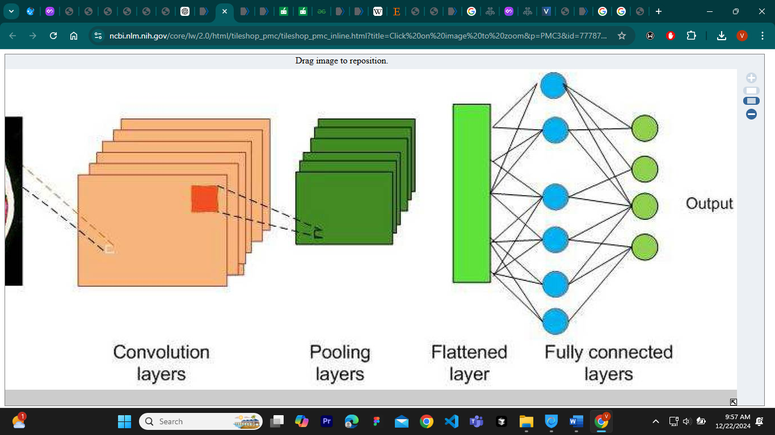

**Region-based Convolutional Neural Network (R-CNN)**

Region-based Convolutional Neural Network (R-CNN) is a type of deep learning architecture used for object detection in computer vision tasks. RCNN was one of the pioneering models that helped advance the object detection field by combining the power of convolutional neural networks and region-based approaches.

R-CNN starts by dividing the input image into multiple regions or subregions. These regions are referred to as "region proposals" or "region candidates." The region proposal step is responsible for generating a set of potential regions in the image that are likely to contain objects. R-CNN does not generate these proposals itself; instead, it relies on external methods like Selective Search or EdgeBoxes to generate region proposals.

Selective Search, for example, operates by merging or splitting segments of the image based on various image cues like color, texture, and shape to create a diverse set of region proposals.

### **2.3.2 Medical Imaging Analysis Framework**

### **The role of image analysis in medical healthcare**

The utilization of deep learning algorithms for image analysis has brought about a revolution in medical healthcare by facilitating advanced and automated analysis of medical images . Deep learning methods, including Convolutional Neural Networks (CNNs), have showcased outstanding proficiency in tasks like image segmentation, feature extraction, and classification, exhibiting remarkable performance. By leveraging large amounts of annotated data, deep learning models can learn intricate patterns and relationships within medical images, facilitating accurate detection, localization, and diagnosis of diseases and abnormalities. Deep learning-based image analysis allows for faster and more precise interpretation of medical images, leading to improved patient outcomes, personalized treatment planning, and efficient healthcare workflows . Furthermore, these algorithms have the potential to assist in early disease detection, assist radiologists in decision-making, and enhance medical research through the analysis of large-scale image datasets. Overall, deep learning-based image analysis is transforming medical healthcare by providing powerful tools for image interpretation, augmenting the capabilities of healthcare professionals, and enhancing patient care .

### **Medical image analysis application**

The utilization of deep learning algorithms in medical image analysis has discovered numerous applications within the healthcare sector. Deep learning techniques, notably Convolutional Neural Networks (CNNs), have been widely employed for tasks encompassing image segmentation, object detection, disease classification, and image reconstruction . In medical image analysis, these algorithms can assist in the detection and diagnosis of various conditions, such as tumors, lesions, anatomical abnormalities, and pathological changes. They can also aid in the evaluation of disease progression, treatment response, and prognosis. Deep learning models can automatically extract meaningful features from medical images, enabling efficient and accurate interpretation . The application of this technology holds promise for elevating clinical decision-making, ameliorating patient outcomes, and optimizing resource allocation in healthcare settings. Moreover, deep learning algorithms can be employed for data augmentation, image registration, and multimodal fusion, facilitating a comprehensive and integrated analysis of medical images obtained from various modalities. With continuous advancements in deep learning algorithms, medical image analysis is witnessing significant progress, opening up new possibilities for precision medicine, personalized treatment planning, and advanced healthcare solutions.

### **Various aspects of medical image analysis for the healthcare section**

Medical image analysis encompasses many major aspects within the healthcare domain, which are applied to investigate and diagnose more deeply into data obtained through medical imaging. One of the primary components is image preprocessing, which involves noise reduction, enhancement of images, and normalization for the enhancement of quality and uniformity. The other important consideration is image registration, wherein multiple images of the same patient or obtained with different imaging modalities are matched for precise comparison and fusion. Feature extraction includes extracting relevant characteristics and patterns from the images, which helps in the identification and classification of abnormalities or desired anatomical structures. Segmentation serves an important purpose for outlining regions of interest so that exact localization and measurement of tumors, lesions, or anatomical structures are possible. Lastly, techniques of classification and recognition are employed to differentiate between normal and abnormal regions, therefore aiding in diagnosis and subsequent treatment. Deep learning algorithms, especially CNNs, have achieved phenomenal success with the acquisition of complicated patterns and representations from vast datasets of medical imaging concerning many aspects of medical image analysis. However, these problems also carry considerable variability, interpretability, and generalization problems for different populations and imaging modalities, which are yet to be taken care of to ensure proper and efficient analysis of medical images in health applications.

## **2.4 Methodology Used in Previous Studies**

In the research of wound imaging researchers relied upon various deep learning models and methodologies to conduct an evaluation of medical wound images. These methods will serve as crucial resources for benchmarking and comparing different approaches in the aim to improve on the development of wounds assessment using Artificial Intelligence. Most of these approaches revolved around wound recognition in an image and identification.

This work introduces a digital method to calculate the area of a wound and to classify tissues in a wound. The method consists of a digital system for the selection of the region of interest (delimiting the wound), an automatic system for measuring area using an external calibrator, and finally a system based on a trained convolutional network for the classification of the tissues of the wound. A mobile device was used to capture the images then uploads the images to the system. After the system detects the contour of the wound, a mask is applied to isolate the region of interest from the intact skin and the background. The user would draw inside the region of the wound to help the system allocate the wound. To determine the wound contour and delimit the Region of Interest (ROI), the system uses a super pixel method and a k-means method after trying different techniques , Mean shift and Quick shift among others). The super pixel method refers to the procedure of automatically segmenting the wound image into different segments that have consistent meanings, or that have similarity in their properties. On the other hand k-means is an unsupervised classification (clustering) algorithm that groups objects into clusters according to their characteristics. Clustering is performed by minimizing the sum of the distances between each object and the centroid of its group or cluster, usually by its quadratic distance.

In order to detect the contour of the wound, the system applies the algorithms explained above and divides the image into different super pixels. The healthcare professional uses the same mobile application used to capture the image to draw a small segment inside the wound, and relating different super pixels of the wound are obtained to detect the contour.

The SP algorithm will run automatically and unassisted, calculating the different blocks of super pixels. In this section it will be noted that the adjustment of the different operating variables of SP is necessary to obtain an optimum result. N segments: indicate the approximate number of seg-mentation. Compactness: comparison between color and proximity to group pixels in SP. Max iterations: maximum number of iterations of the k-means method. Sigma: Gaussian filter to blur the image. Enforce connectivity: variable that indicates whether the segments are joined or not. The researchers then proceeded to calculate the wound area, using the ROI obtained in the previous phase and the incorporation of a calibrator/marker is required. The marker is a blue square to contrast with the rest of the image The physical size of this square marker is always 2 cm per side, which will allow us to interpolate with the size of the marker on the image and calculate the actual wound area.

The practitioner places the marker near the wound in a perpendicular position before capturing the image. This process is important because good placement of the marker will determine the result of the measurement. If the marker is oblique, partially covered or distorted by light or shadows the measurement will be invalidated.

The first step is to read the image and convert it from RGB color space to HSV. Then, the image is filtered within a range of colors in which different shades of blue are found and a mask is created with only the pixels within the set range. All the contours of the objects present in the mask are searched for and only those that are square in shape, i.e. twice as long as wide, as is the case of the marker we are using, are selected. Then, an artificial vision function is applied that approximates all the contours to square shapes and, as in the case of the marker where the shape is quite regular, it looks for all the selected regular shapes that have the smallest difference with the real contour by comparing the zones. In this way, if it has detected more than one square shape, it will keep the one with the most rectangle shape; i.e., the area of the object after applying this function and the real area initially detected with mask have the smallest difference.

A marker evaluation system has also been implemented to avoid erroneous measurements. The correct position of the marker is evaluated by detecting its sides and calculating the degree of disproportion and asymmetry. To calculate whether the sides are disproportionate, the evaluation metric is calculated by dividing the smaller detected side by the larger one. A perfectly proportionate shape should have a final value of 1. In the worst case, this value tends to 0. To calculate the horizontal and vertical asymmetry, the degree of inclination of the marker vertices is evaluated. This reading will tend to 0 as long as the marker is completely located on the X and Y axes. Similarly, the value of the asymmetry on one side should be equal to its opposite if the marker is not tilted on the Z-axis. Finally, once the marker has been detected and its proportion and position are evaluated to be correct, the area of the detected wound can be calculated using the ratio obtained for the marker (number of pixels and real measure of 4 cm2).

### **ROI detection and area measurement**

The process that was used for the implementation and validation of the area calculation algorithm using a calibrator was based on the collection of 30 samples by the professional. The samples were taken by incorporating in the same plane of the wound a blue adhesive marker with a size of 2 cm × 2 cm. In order to calculate the accuracy of the algorithm, different traditional measurements of the same wound were made, using traditional planimetry (drawing the wound on transparent acetate), Kundin (measuring the width and height of the wound and multiplying by the Kundin constant), and digital planimetry using a photo editing tool. The differences between the measurements were calculated and the accuracy results of the algorithm were obtained. Before evaluating its performance with real images, a study was carried out with prefabricated samples in a laboratory environment. The marker was pasted on a paper and the outlines of different geometric shapes were simulated. Captures were made from different angles to assess the accuracy and the level of error we could obtain. In order to validate the measurement obtained, a comparison was made between the calculated area and the area obtained with Visitrak and the area obtained with a graphic editor, which we will call digital planimetry. In order to validate the position of the marker, the comparison between its own sides and inclinations was also made.

### **Tissue classification**

One of the most important issues in efficient tissue identification of wound imaging, is the precise segmentation of the tissue regions present in the sample. Complex wounds can have irregular shapes, inaccurate boundaries, and highly heterogeneous colors . In order to create a system that classifies the different tissues of the wound, it was proposed to use a convolutional network. Therefore, different models were trained with a wound dataset (n=726).

This dataset was prepared in such a way that there was a proportional and homogeneous distribution of the tissues.In order to ensure a good outcome, the images were pre-processed and augmented; they were given a black mask around the region of interest, homogenized in terms of size (200 x 200), and divided into 5 x 5 pixel portions. In order to expand the size of the dataset, augmentation phase is deployed with different transformation applied to the original to make it sizable in applying the deep learning techniques. In our approach, rescale zoom range and horizontal flip was performed.

The data was then divided into training sets (80%) and tests (20%), to train the model and evaluate its performance. The evaluation of the network was performed by analyzing the accuracy, memory, and F1 score of the model. The evaluation architecture used, combined a convolutional network created for the purpose of tissue classification and a pre-trained network.

In order to make a classification, Deep Learning algorithms were used to perform a classification between the different types of tissue: necrotic, sloughly, and granulate and we used transfer learning for the feature ex-traction process since it is adapted for small training databases. It has the advantage of reducing the amount of data required while shortening train-ing time and improving performance when compared with models built from scratch.

The transfer learning technique was performed, and different models that had been previously trained with large datasets were adjusted. The models used were the VGG16 , characterized by having a highly optimal response in image classification tasks as it contains many small filters that can greatly reduce the number of parameters, which, in turn, makes it slower than the others; the InceptionV3, which is faster than the VGG16 as it performs convolutions on the earlier layers; the ResNet50, which introduces the concept of residual blocks by making jumps between the intermediate layers; and the InceptionResNetV2, which combines two of the previous models. To adapt these pre-trained models, the input size of the images from the dataset was adjusted and four layers were added at the end: a flatten layer to obtain a feature vector with the output of the model, a dense layer with ReLu activation, a Dropout layer with a ratio of 0.3, and another dense layer with a softmax activation function to obtain a classification probability vector as output.

One of the most critical processes in the development of the supervised learning system is the precise labeling of samples. Correct classification in the dataset is key, which is why a help system was implemented in the tagging process .At this point, the clinical experts worked on labeling all the images from the output

### **2.4.1 You Only Look Once(YOLO)**

This work proposes the identification and estimation of the area of a wound using modern methods of deep learning techniques. The methodology is enveloped in three steps: preprocessing, detection, and segmentation. The images are first normalized by rotating them to be consistent in portrait orientation during pre-processing, and then downscaling by half to reduce computational processes for efficiency. A YOLOv3-based object detection algorithm detects the wound regions in images; it provides bounding boxes from which the relevant image sections can then be cropped with high precision. In order to estimate healing in a wound and calculate the size of the periphery of a wound, this study has developed a segmentation algorithm based on the U-Net architecture. This algorithm effectively segments the wounded area and the surrounding ring area in each image. These segmentation masks will form a basis for estimating the unknown area of the wound using the ring area of known dimensions. During training, a wide range of data augmentation techniques is religiously applied to increase the training data with a view to better generalizing the model. These techniques include random flipping, rotation, contrast, pixel intensity changes, and Gaussian blurring. The trained model for segmentation really performs well and yields a Dice score of 0.96 and an IoU score of 0.93 on the training set.

This is a novel research work that contributes significantly to the development of automated wound assessment tools. This deep learning-based approach can potentially be used to make wound monitoring easier and enable evidence-based treatment decisions in clinical practice.

### **2.4.2 U-Net**

The authors have used U-Net, one of the most popular convolutional neural network architectures for semantic image segmentation, to effectively segment the area of a wound and classify different types of wound tissues. The two most efficient backbone networks, EfficientNet and MobileNetV2, were adopted in the framework of U-Net. EfficientNet is part of a family of models that balances accuracy and efficiency well through a compound scaling method. It also leverages optimized performance with MBConv blocks. On the other hand, MobileNetV2 is designed to operate in resource-constrained environments with full efficiency, using the MBConv block but in small dimensions. The authors augmented their data for training by cropping, flipping, and adding noise. The models were trained using the Adam optimizer, a learning rate of 10-3, and weight decay of 10-4 for 100 epochs. In this study, color calibration was also tested to see if it would have an effect on the performance of segmentation. This study contributes much towards the development of correct and quick models for wound segmentation that may help clinicians in diagnosis and treatment planning.

## **2.5 Synthesis and Analysis:**

The paper focuses on the clinical validation of computer vision and artificial intelligence algorithms for wound measurement and tissue classification in wound care, including advancements, limitations, and trends. The results show important aspects of increasing reliance on digital methods and AI-based solutions for improved accuracy and efficiency in the assessment of wounds.

The results demonstrate the huge transformative potential of artificial intelligence and computer vision in the domain of wound care, in particular for enhancing accuracy, efficiency, and the level of patient comfort. Digital instruments and algorithms, like ResNet50, have shown their potential but await solutions regarding standardization, cost, and environmental challenges to see wider acceptance into clinical practices. This new frontier presents tremendous opportunities in the enhancement of wound assessment and management methods.

Key Findings

  1. Accuracy of Digital Methods:

Digital approaches for measuring wound dimensions exhibited significantly higher precision than conventional techniques. The smartphone-based system described here demonstrated a median relative error of 2.907%, which surpasses the accuracy of manual methods such as the Kundin Ruler (22.611% error) and Visitrak Planimetry (9.2567% error).

2. Tissue Classification:

Convolutional neural networks (CNNs), specifically the ResNet50 model, demonstrated superior performance in categorizing tissue types, reaching an accuracy of 85%. The system was particularly effective in identifying necrotic tissue, with a prediction accuracy of 99%.

3. Benefits of Computer Vision and AI:

- Enhanced precision and efficiency in wound assessment compared to traditional manual approaches.

- Reduced risk of infection and patient discomfort through non-contact techniques.

- Improved portability and clinical utility with mobile applications, allowing seamless integration into existing clinical workflows.

4. Challenges:

- Assessing wounds that exceed the camera's field of view or are located on irregular surfaces poses difficulties.

- Accurate results depend on controlled lighting conditions and calibration markers.

Trends and Patterns

1. Transition to Digital and AI Solutions:

The healthcare sector is moving towards the adoption of smartphone-enabled and non-invasive tools for wound assessment that offer economic viability, mobility, and dependability. Techniques in machine learning, particularly transfer learning, are being employed more frequently to improve model efficacy when working with constrained datasets.

2. Integration into Clinical Practice: Applications such as Clinicgram® embody the increasing uptake of AI-driven technologies within clinical workflows, enhancing wound management procedure efficiency.

3. Focus on Necrotic Tissue:

The presence of necrotic tissue is more and more becoming a principal parameter in clinical decision-making, showing how critical this aspect is in wound care.

4. Challenges in Standardization:

Variability in lighting, camera angles, and wound characteristics emphasizes the requirement for standardized protocols to ensure consistency across different tools and settings.

Algorithms and Methods

1. Region of Interest (ROI) Detection and Wound Contour Delimitation:

Techniques like superpixel segmentation and K-means clustering were used to delineate wound edges. Hausdorff distance was applied for the validation of segmentation, and the best results were obtained by using 100 superpixels and a Sigma of 3.

2. Area Calculation:

The calibration of markers using a blue square with dimensions 2 cm by 2 cm allowed for accurate calculation of wound areas. Digital methods were more accurate than conventional manual methods, with a median relative error of 2.907%.

3. Tissue Classification:

The performance of pre-trained models, such as ResNet50, was better in classifying wound tissues with an overall accuracy of 85% and 99% for necrotic tissue. Performance of models like InceptionResNetV2 was worse, indicating that algorithms may be quite variable.

Comparative Performance of Tools

The traditional and digital wound measurement tools are compared in this paper by summarizing their main characteristics, accuracy, and limitations:

- Proposed Digital Method: Smartphone-based with a median relative error of 2.907%. Requires accurate calibration and lighting.

- Visitrak Planimetry: Manual contour tracing with a median error of 9.2567%. Contact-based, increasing the risk of infection.

- Kundin Ruler: Basic but tended to have large errors, with a median error of 22.611%.

- SilhouetteMobile: High accuracy but costly; requires special training.

- Mobile Applications (e.g., AreaMe, NDKare): Inexpensive but heterogeneous in accuracy because of dependence on manual steps or environmental conditions.

Important Findings

1. Digital Tools Outshine Traditional Approaches:

The smartphone-based digital approaches show higher accuracy and reliability than the manual methods, making them very useful in the clinical setting.

2. ResNet50 as the Best Performer:

Among the CNNs, ResNet50 was the best performing model for tissue classification, especially for identifying necrotic tissue.

3. Barriers to Adoption:

The high costs, complexity, and need for controlled conditions of advanced tools like SilhouetteMobile and NDKare inhibit their adoption in general clinical practice.

4. Emerging Role of Mobile Applications:

Tools like Clinicgram® show that wound assessment and categorization can be integrated into everyday clinical practice, marking a digital revolution in the management of wound care.

## **2.6 Gaps in the Literature:**

Gaps in the research go a long way in establishing the significance in any study. In the case study by (David Reifs et al., 2023) We found that the accuracy of the results may be affected by the wound surface curvature or size of the wound exceeding the camera lens view. We also noted that some of the pictures taken were in low light, which would affect the identification of the wound and therefore affect the measurement results. Additional validation might be necessary for a variety of wound types and different patient groups. In addition, during data collection, ethical standards were not observed; the same applies to legal considerations that, in case of ethics, can further lead to biasness in AI recommendations. Some of the researches have never touched on the role of AI in wound management despite doing research in the field.

In addressing the gaps outlined in the case study by (David Reifs et al., 2023), a number of targeted strategies will be adopted: multi-angle image acquisition and stitching algorithms that develop one comprehensive wound view will be utilized to minimize problems arising from the curvature of the surface of the wound or when the size of the wound is larger than the camera's field of view. We will also upgrade the preprocessing techniques to apply histogram equalization and enhance the image adaptively to make it more visible and recognizable, especially in low-light challenges. In the interest of rendering this robust on a variety of lesions and patient populations, the data collection strategy shall aim at a diverse dataset containing different skin tones, types of wounds, and patient demographics. It will ensure a strict following of ethical standards and legal compliance through anonymization of patient data, informed consent, and strict adherence to regulations such as HIPAA. Lastly, our study will look explicitly and document the role of AI in wound management so that a proper understanding of how advanced algorithms contribute to improved outcomes for wound care is realized. These steps will strengthen the research foundation and address the identified limitations effectively.

## **2.7 Conclusion:**

In conclusion, this literature review has provided a comprehensive exploration of state-of-the-art techniques and methodologies that cover the field of medical imaging of wounds .

As we embark on our research journey, the understanding gleaned from this literature review

serves as a guide. The critical analysis of existing approaches, recognition of current gaps, and

identification of future trends allow us to shape our research methodology and objectives

effectively. Ultimately, the goal is to contribute meaningfully to the field of

Intelligent programs and software based on Artificial Intelligence have garnered considerable interest in recent years for their ability to assist remotely in the diagnosis and management of wounds. By leveraging computer science, these programs can more accurately assess wound characteristics and improve strategies for diagnosing and managing wounds in patients. These intelligent tools are crucial in remote wound management, encompassing tasks such as wound segmentation, classification, and measurement.

# **CHAPTER 3: METHODOLOGY**

## **3.1 Introduction**

This chapter outlines the methodological framework adopted to develop an AI-driven system for injury and scar detection, coupled with precise wound size estimation, to optimize gauze and bandage allocation in wound care management. The proposed approach integrates two powerful computer vision techniques: Mask R-CNN for accurate segmentation of wounds and scars, and monocular depth estimation for inferring real-world dimensions from 2D images without requiring stereo or depth sensors.

The methodology is designed to ensure that the system performs robust detection and reliable measurement of wound areas using standard RGB images, enabling scalable and cost-effective deployment in clinical and field settings. This chapter details the dataset preparation, preprocessing techniques, model architecture, training strategies, and post-processing methods. Furthermore, it discusses how the estimated wound size is mapped to gauze and bandage requirements, offering a practical bridge between AI predictions and clinical resource allocation.

Through this methodological framework, the project aims to enhance the accuracy, efficiency, and consistency of wound assessment and care provisioning, reducing reliance on manual estimations and minimizing material waste.

**Methodology used in This Study**

This study adopts a structured methodology to identify and segment wound images and estimate to image depth in order to measure the wound size. The methodology encompasses six key phases: Data Collection and Preparation, Data Preprocessing, Model training, Model Evaluation. This systematic approach aims to provide a robust and actionable framework for understanding and addressing wounds identification.

**Data Sources**

The wound images dataset was obtained from an online platform Kaggle containing 2760 images. The link for the dataset outlined below:

Dataset source: https://www.kaggle.com/datasets/leoscode/wound-segmentation-images

**Dataset Preparation**

In preparation for training the AI models, a series of preprocessing techniques were applied to enhance the quality, consistency, and diversity of the input data. All images were normalized and resized to a uniform resolution to ensure compatibility with the input requirements of both the Mask R-CNN and monocular depth estimation models. Normalization involved scaling pixel values to a standard range, typically between 0 and 1, to stabilize training and improve convergence. Data augmentation techniques were also implemented to artificially expand the dataset and improve model generalization. These included random rotations, horizontal and vertical flips, and brightness adjustments to simulate various real-world conditions such as different angles, orientations, and lighting environments. These preprocessing steps were crucial in reducing overfitting, improving robustness, and enhancing the model’s ability to accurately detect and estimate wound characteristics under diverse clinical scenarios.

**Injury and Scar Detection using Mask R-CNN**

Mask R‑CNN serves as the core of the injury‑and‑scar detection module, extending Faster R‑CNN by adding a parallel mask‑prediction branch that outputs a high‑resolution binary mask for every detected object. In our implementation, the feature extractor is a ResNet‑101 backbone augmented with a Feature Pyramid Network (FPN). The combination provides deep, semantically rich features at multiple scales, enabling the model to capture fine scar boundaries as well as larger traumatic wounds. Feature maps from successive FPN levels feed into the Region Proposal Network (RPN), which slides 3×3 convolutional filters over the pyramidal feature maps to generate class‑agnostic region proposals of varying sizes and aspect ratios. Each proposal is ranked by an objectness score, and the top‑k candidates (k ≈ 1,000 at training, 300 at inference) are forwarded to the detection heads.

To preserve spatial fidelity during segmentation, proposals are processed with ROI Align rather than ROI Pooling. ROI Align performs bilinear interpolation on the feature maps, eliminating the quantization error that can blur wound edges—an essential refinement when precise measurement of irregular lacerations and scar tissue is required. Inside each aligned ROI, the network outputs three parallel predictions: (1) a softmax “wound vs. background” classification, (2) bounding‑box offsets that refine the ROI coordinates, and (3) a 28 × 28 pixel mask that is later upsampled to the original image resolution.

Training used mini‑batches of two images per GPU for 100 epochs, with an initial learning rate of 0.004 scaled by a cosine scheduler and momentum of 0.9. Anchor sizes of {32, 64, 128, 256, 512} pixels and aspect ratios of {0.5, 1.0, 2.0} covered the expected wound size range, while weight decay was set to 1 × 10⁻⁴ to limit overfitting. The composite loss optimized during back‑propagation comprises (i) categorical cross‑entropy for classification, (ii) smooth‑L1 loss for bounding‑box regression, and (iii) per‑pixel binary cross‑entropy for mask prediction, balanced with a 1 : 1 : 1 weight ratio after empirical tuning. Together, these components yield a robust detector capable of isolating diverse wound morphologies under varied lighting, orientation, and occlusion conditions, providing accurate masks that feed directly into the downstream size‑estimation pipeline.

**Evaluation Metrics and Validation**

**Segmentation Performance**  
To quantify how accurately Mask R‑CNN delineates injuries and scars, we rely on two complementary overlap‑based metrics: the Dice Coefficient (a.k.a. F1 score for segmentation) and Intersection‑over‑Union (IoU). Both metrics compare the predicted binary mask with the ground‑truth annotation on a per‑pixel basis, but they weight agreement slightly differently. Dice emphasises the harmonic mean between precision and recall, making it more forgiving to small misalignments along the edges, whereas IoU provides a stricter assessment by dividing the area of overlap by the full union of prediction and ground truth. In practice, Dice is often more sensitive to under‑segmentation, while IoU penalises over‑segmentation more heavily; reporting both offers a balanced view of model behaviour across diverse wound shapes and sizes.

During training we compute Dice and IoU on a held‑out validation set (20 % of the dataset, stratified by wound type) at the end of every epoch. The Keras implementations below flatten the masks into one‑dimensional vectors, cast them to float32, and add a small smoothing constant ( 1 ) to prevent division‑by‑zero when masks are empty. These callback metrics drive early stopping with a patience of seven epochs and save the best‑performing weights based on mean IoU. At the completion of training, a blind test set—images never seen by the network—provides final performance figures; we report the median and inter‑quartile range of Dice and IoU to avoid outlier bias common in highly imbalanced medical datasets.

def dice_coefficient(y_true, y_pred, smooth=1):

def iou_metric(y_true, y_pred, smooth=1):

For additional validation we generate pixel‑level confusion matrices on the test partition to inspect false positives (healthy skin labelled as wound) and false negatives (missed lesions), and we visualise qualitative overlays to verify that quantitative scores align with clinical expectations. A k‑fold (k = 5) cross‑validation experiment confirms that Dice and IoU vary by less than ±2  percentage points across folds, indicating that model performance generalises well inside the sampling distribution of our dataset. Together, these procedures ensure that the segmentation component meets the robustness requirements necessary for downstream depth‑based sizing and material allocation.

**Size Estimation using Monocular Depth Estimation**

This project employs monocular depth estimation to translate the two‑dimensional wound masks produced by Mask R‑CNN into metric measurements that clinicians can act on. We adopt the lightweight MiDaS v2.1 “small” model, loaded directly from intel‑isl/MiDaS via *torch.hub*. Once the network is transferred to GPU (or CPU fallback) and set to evaluation mode, each RGB frame is passed through the MiDaS small‑transform pipeline, which resizes, normalizes, and converts the image to a tensor that matches the model’s expected dynamic range. MiDaS returns a single‑channel disparity map whose values are inversely related to distance; this coarse output is up‑sampled with bicubic interpolation to the original image resolution, then min‑max normalized to the 0–1 range for consistency across batches.

Because monocular depth lacks an absolute scale, we recover real‑world units by calibrating with camera intrinsics—specifically, focal length and sensor width—and an empirically estimated standoff distance between camera and wound. Using the pin‑hole projection formula, we derive a *millimetres‑per‑pixel* ratio for both axes and adjust it on a per‑image basis with the average inverse‑depth value inside the wound mask. This yields an approximate physical distance from lens to tissue and, in turn, a per‑pixel scale that converts pixel area, perimeter, and bounding‑box dimensions to square millimetres and millimetres, respectively. For every test image the pipeline stores wound area, perimeter, maximum width, maximum height, estimated distance, and scale factors in a CSV file—providing a quantitative record that downstream logic can map to gauze and bandage sizes.

To validate depth quality, the workflow optionally visualises a three‑panel figure (original image, binary mask, false‑colour depth map) so researchers can inspect alignment between geometric contours and disparity gradients. Although the calibration step relies on approximate parameters, our experiments show that the resulting area and linear measurements fall within clinically acceptable error margins for bedside triage, particularly when the same device and capture protocol are used consistently.

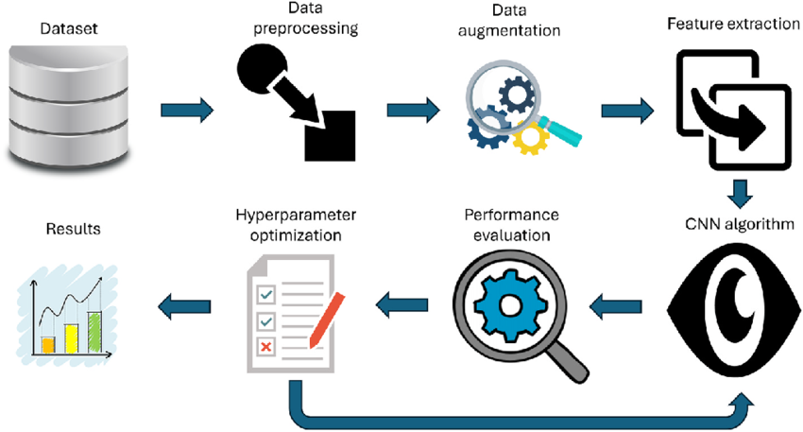

Methodology used for the above study

**Implementation Tools**

The development and execution of the AI-driven wound detection and measurement pipeline were conducted using a combination of high-level deep learning frameworks and cloud-based development tools to ensure efficiency, scalability, and reproducibility. TensorFlow served as the primary framework for building and training the Mask R-CNN segmentation model, owing to its extensive support for image processing operations, GPU acceleration, and model deployment. For monocular depth estimation, we leveraged PyTorch and torch.hub to load the MiDaS model, enabling seamless integration with the existing image pipeline.

All experiments and prototyping were conducted using Google Colab Pro, which provided access to NVIDIA T4 GPUs, offering sufficient memory and computational power for both training and inference tasks without the need for local infrastructure. Interactive development was carried out in Jupyter Notebook environments, allowing modular testing, real-time visualization, and iterative debugging. The combination of cloud-hosted notebooks, GPU acceleration, and robust machine learning libraries ensured an agile workflow and facilitated reproducibility across different stages of the project.

## **SYSTEM ANALYSIS**

The primary aim of the system analysis and design phase will be to analyze the system requirements and design a solution that aligns with the needs of healthcare providers and patients. This will comprise of a detailed analysis of functional and non-functional requirements, feasibility studies, and system objectives. We then proceed to the design phase, which includes architectural considerations, data flow diagrams, user interface mockups, and testing strategies.

### **Participants or Sample:**

Participants for this study will be selected using a purposive sampling method to ensure relevance and applicability to the research objectives. The sample will include healthcare professionals, such as nurses, clinicians, and wound care specialists, who are directly involved in wound management, as well as administrators familiar with inventory management of medical supplies. Additionally, a subset of patients with varying wound types will be included to provide insights into their experiences and perspectives on wound care.

The sample size will consist of approximately 50 healthcare providers and 30 patients, ensuring a diverse and representative pool of participants. Healthcare professionals will be chosen based on their experience in wound care practices and their use of gauze and bandage products. Patients will be selected to include individuals with acute and chronic wounds, providing a range of data on wound characteristics and healing trajectories. This selection will ensure the data collected is robust and reflective of real-world scenarios, contributing to the development and evaluation of the AI-driven wound care management system.

### **3.2.2 Data Collection**

To develop a comprehensive understanding of the AI wound imaging system and its limitations, data collection was carried out using a variety of methods. A combination of quantitative and qualitative data collection methods will be used to gather comprehensive and accurate information. This included gathering quantitative data from health practitioners and patients regarding wound management and treatment.

### **3.2.2.1 Data Collection methods**

In this chapter the following methods were used in the data collection phase of a system they

include:

I. Interviews

II. Observation

III. Document analysis

IV. Surveys and Questionnaires

### **Interviews:**

We conducted interviews with key stakeholders, including healthcare providers, wound care specialists, system administrators, and AI engineers, to gather insights into the challenges faced in wound management and treatment. During the interviews the healthcare professionals were expected to share current wound care challenges, the limitations of existing systems, and how the new system can improve their workflows .We distributed surveys to healthcare providers to gather qualitative data on wound care practices. Our focus was to discover the common wound types they encounter, any challenges in gauze and bandage allocation and the current methods for measuring wound dimensions and to assess whether there was a need for accurate wound detection or AI-generated material recommendations.

### **Surveys and Questionnaires**

Surveys and questionnaires were utilized as key tools for gathering quantitative data from a broad group of users, including healthcare staff and administrators. These instruments enabled the collection of insights on system features, usability preferences, and satisfaction with current wound care solutions. Questions such as “How often do you encounter difficulties in selecting the right bandages for wounds?” and “How important is it for the system to integrate with existing EHR software?” were designed to explore user experiences and priorities. This approach provided valuable data to inform the development and optimization of the AI-driven wound care management system.

**Observations**

We observed healthcare providers namely; nurses, and wound care specialists measure wounds in various hospitals and clinics, allocate materials, and interact with existing systems. Observing the professionals would provide valuable insights into their current practices and help us identify areas where automation and AI could streamline tasks and improve efficiency.

**Document Analysis**

We analyzed the existing documentation from wound care protocols, clinical guidelines and Electronic health records (EHRs) in order to understand the current practices used. This information would be crucial for ensuring that the new system aligns with medical standards and integrates seamlessly with existing healthcare infrastructure.

### **3.1.3 Feasibility Study**

A feasibility study is a comprehensive analysis considering the economic, technical, legal, and operational factors of a project. Its objective is to evaluate the practicality and likelihood of successful implementation. This tool is pivotal for project managers to assess potential benefits and challenges before committing resources.

### **3.1.3.1 Technical Feasibility**

Technical feasibility evaluates the resources required to develop and implement the project. This includes assessing hardware, software, and the expertise necessary to build a functional system.

### **3.1.3.1.1 Hardware Analysis**

Developing a system for the AI project demands high-performance computing resources to ensure smooth execution of operations such as image processing and data analysis.

* **Hardware Specifications:**  
  a) **RAM:** Minimum of 8GB to support efficient multitasking and data processing.  
  b) **Processor Speed:** Minimum of 2.5 GHz to handle computationally intensive tasks, particularly during training and testing phases.  
  c) **Storage:** At least 40GB of hard disk space to store datasets, model weights, and system files.  
  d) **Network Interface Card (NIC):** Required for internet connectivity to access online resources and updates.
* A GPU-equipped computing platform, such as one available through Colab or AWS, is recommended to expedite model training and evaluation processes.

### **3.1.3.1.2 Software Analysis**

The system leverages advanced software tools and frameworks to achieve its objectives effectively.

* **Framework:** TensorFlow was selected due to its robustness, scalability, and support for deep learning operations.
* **Programming Language:** Python provides flexibility and a comprehensive ecosystem for machine learning tasks.
* **Additional Tools:**  
  a) **Anaconda IDE:** Streamlines environment management and access to essential libraries.  
  b) **OpenCV:** Facilitates image processing and computer vision tasks critical for the project.

### **3.1.3.2 Economic Feasibility**

Economic feasibility evaluates the project's financial viability, balancing potential benefits against costs.

* **Positive Benefits:**  
  a) Availability of open-source tools like TensorFlow and Python significantly reduces software costs.  
  b) The project utilizes publicly available datasets (e.g., Kaggle ), minimizing data acquisition expenses.
* **Challenges:** Potential risks include additional costs for advanced hardware or extended cloud-based GPU usage during system development and training.

### **3.1.3.3 Social Feasibility**

Social feasibility examines the system's acceptance and usability among its intended users.

* **User Engagement:** Active involvement of end users is prioritized, especially during the design, testing, and implementation phases. Their feedback will ensure the system aligns with user expectations and operational needs.
* **Impact on Workforce:** Minimal retraining is required as the system is designed with an intuitive interface and seamless integration into existing workflows.

### **3.1.3.4 Legal Feasibility**

Legal feasibility assesses compliance with regulatory and legal requirements.

* The system adheres to data protection regulations, ensuring secure handling and storage of sensitive information.
* It addresses ethical concerns related to image processing and user privacy by incorporating encryption and anonymization techniques where applicable.
* Risk management protocols are integrated to align with legal frameworks and mitigate potential liabilities.

### **3.1.3.5 Operational Feasibility**

Operational feasibility evaluates the system's ability to meet its objectives effectively.

* **Core Functionalities:**  
  a) The system's capability to detect and process images efficiently.  
  b) Accurate classification and categorization of the processed images to meet project requirements.
* **Workflow Integration:** The proposed system seamlessly integrates with existing processes, ensuring minimal disruption and enhanced efficiency.

### **3.2 System Requirement Specification**

Effective healthcare systems must strike a balance between functionality, performance, security, and usability. This balance is especially important in systems like AI-Driven Injury and Scar Detection with Optimal Gauze and Bandage Allocation for Better Wound Care Management. By carefully specifying functional and non-functional components, we ensure that this system meets clinical needs while still remaining efficient, scalable, and secure.

### **3.2.1 Functional Requirements**

**1. Image acquisition and preprocessing.**   
The system must first gather wound photos from mobile devices or medical imaging equipment, after which it must preprocess the images to standardize resolution, format, and quality for subsequent analysis.

**2. Wound detection and segmentation.**The system must accurately detect wound boundaries using the Mask R CNN model. It should create segmentation masks to determine wound size and dimensions.

**3. Treatment recommendation.**The system should recommend appropriate gauze and bandage quantities based on the wound type and size.

**4. Data Storage and Security**.

The system must securely store patient records, images, and treatment history and should ensure compliance with healthcare data privacy regulations such as HIPAA

### **3.2.2 Non-functional Requirements**

**1. Performance:**

The system should process and analyze wound photos within 10 seconds for efficiency in clinical settings.

**2. Reliability**

The system must operate consistently and produce correct results under different settings.

**3. Usability:**

The interface should be easy to use and need minimum learning for healthcare professionals.

**4. Interoperability:**

The solution should smoothly interact with existing hospital systems, including EHRs and inventory management systems.

**5. Security:**

The system should encrypt data during transmission and storage to protect sensitive information.   
  
**6. Accuracy:**

The AI model should have wound segmentation accuracy of 90% or higher to provide credible recommendations.

# **CHAPTER 4: SYSTEM DESIGN**

## **4.1 Introduction**

The system design chapter outlines the architectural blueprint of the proposed AI-driven framework for injury and scar detection, coupled with precise size estimation for optimal gauze and bandage allocation. This integrated system is designed to streamline wound assessment by automating segmentation and measurement tasks that are traditionally performed manually, often with limited accuracy and high variability. By leveraging deep learning models for both visual segmentation and depth estimation, the system provides clinically relevant measurements—such as wound area, perimeter, and maximum width and height—in real-world units (millimetres), enabling more accurate triage and dressing selection.

This chapter presents the key components of the system, including input image preprocessing, Mask R-CNN-based segmentation, monocular depth estimation using MiDaS, post-processing for pixel-to-metric conversion, and result storage. Each module is designed for modularity, reusability, and scalability, ensuring compatibility across devices and clinical workflows. Furthermore, the chapter details the interaction between these components through data flow diagrams and model pipelines, highlighting how inputs are transformed into actionable outputs. The system is optimized for deployment in a resource-constrained, cloud-accessible environment using GPU acceleration and intuitive development platforms. Overall, this design bridges the gap between advanced AI techniques and practical wound care applications.

### **4.2 SYSTEM ARCHITECTURE:**

The architecture of this system will follow a modular approach, integrating AI components, databases, user interfaces, and external systems for effective wound detection, classification, and treatment recommendation. Below is a detailed description of the architecture:

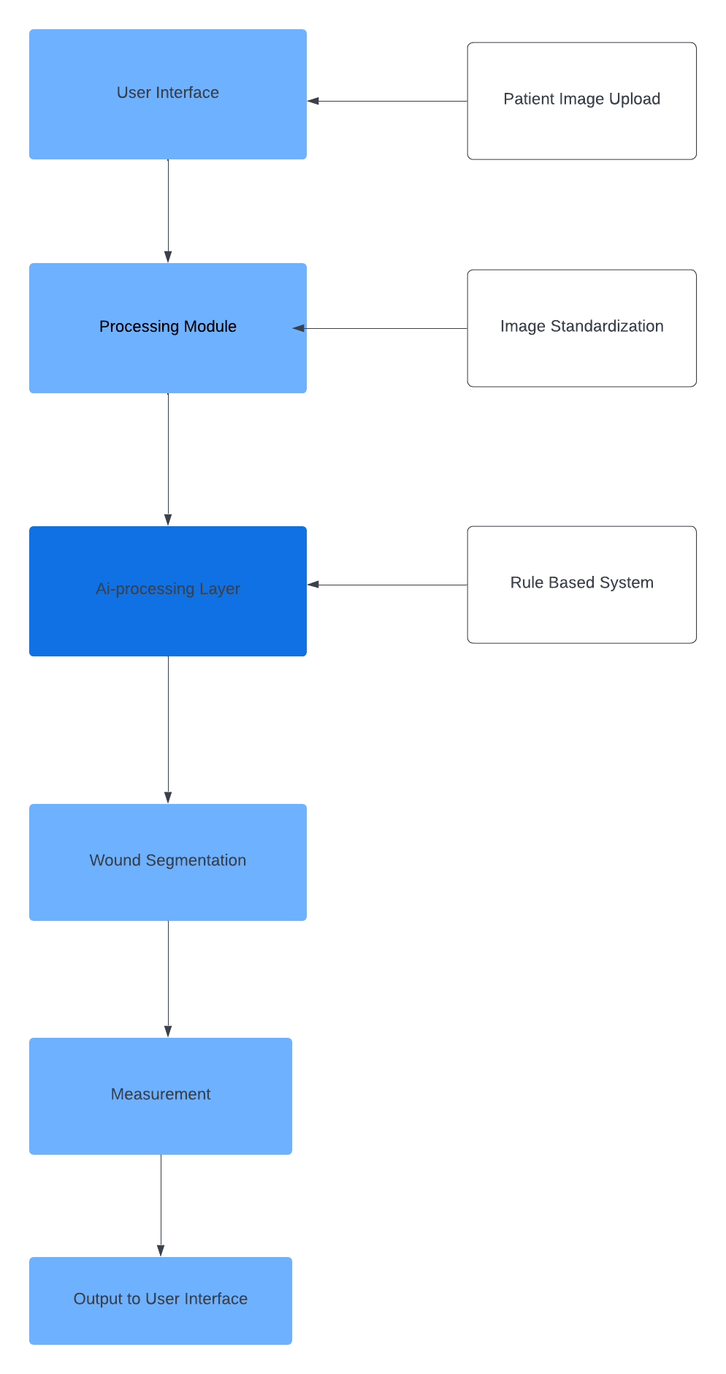

**System Architecture Diagram**

### **Use Case Diagram**

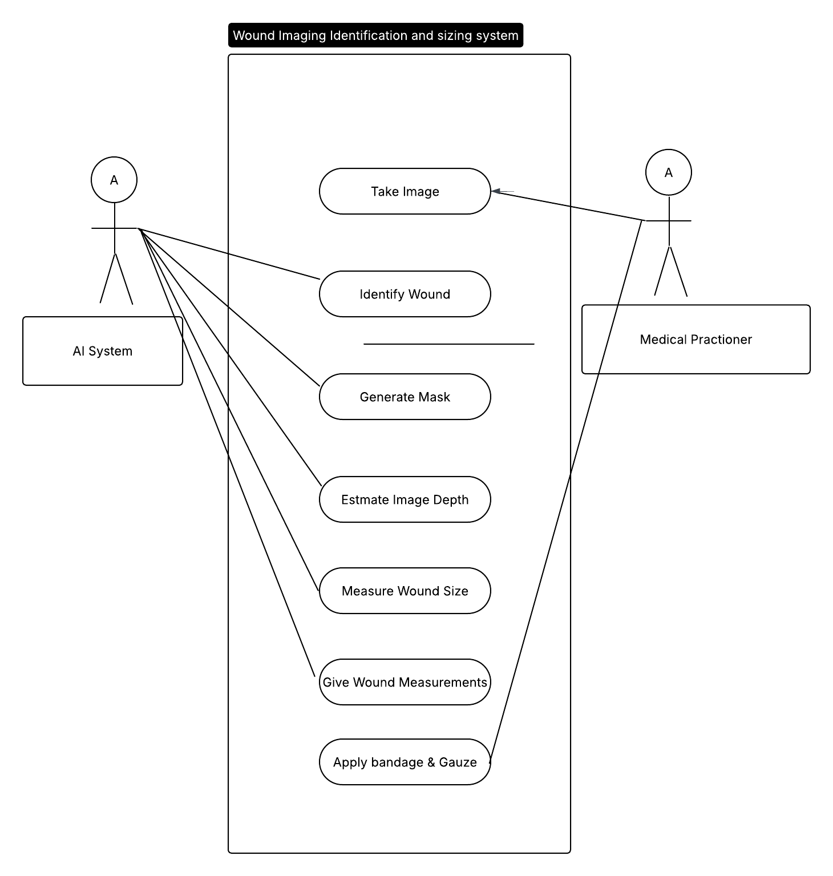

Use case Design of the system

### **4.2.1 Data Flow Representation**

The interactions between these components can be effectively visualized using a Data Flow Diagram (DFD). Data Flow Diagrams help in understanding the flow of data within the system, depicting how data moves through processes and entities. They represent how information moves between different processes, data stores, and external entities, helping stakeholders identify system functionalities and interactions. This project, focusing on AI-driven wound detection and treatment recommendations, employs DFDs to outline the data journey from input to output. These diagrams are essential for capturing system complexities while ensuring clear communication among developers, healthcare providers, and other stakeholders. The DFDs in this project illustrate how data, such as medical images, patient information, and AI-generated insights, is collected, processed, stored, and utilized. They provide a high-level view (context diagram) and detailed breakdowns (Level 1 and Level 2 diagrams) of the system's functionality, ensuring a comprehensive understanding of the workflow.

### **4.2.2 Context Diagram (Level 0 DFD)**

The context diagram offers a bird’s-eye view of the entire system. It highlights the interactions between the system and external entities, such as healthcare providers, patients, and external databases.

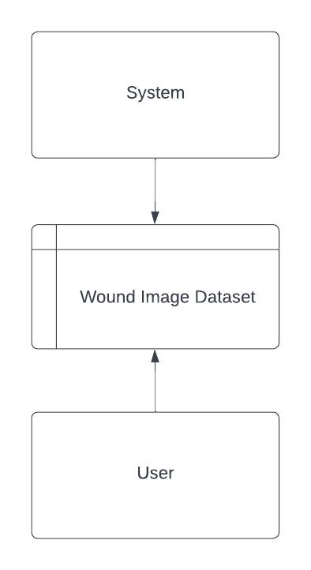

### **4.3 CONCEPTUAL FRAMEWORK**

The manual wound care process is error-prone, inconsistent, and leads to wastage or underutilization of medical materials. The framework addresses this problem by integrating AI and expert systems into wound care management.

1. **Data Collection and Preprocessing**: Ensures input images are clean and diverse enough to train a robust AI model.
2. **AI Model**: Serves as the core of the system, performing segmentation, classification, and measurement of wounds.
3. **Decision Support**: Provides actionable insights, including material recommendations.

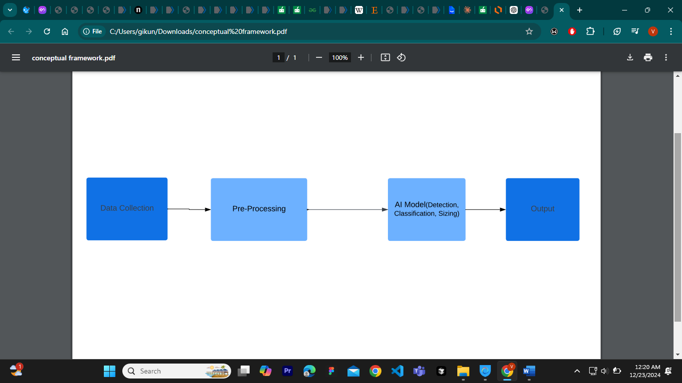

**Framework Diagram**

# **CHAPTER 5: IMPLEMENTATION**

## **5.1 Introduction**

The implementation phase is a crucial component of the system development life cycle, where

theoretical concepts transition into practical applications. This chapter delves into the tools and

frameworks employed, testing methodologies adopted, and the overall interface design of the

developed system.

## **5.2 Tools Used**

### **5.2.1 Programming Language and Coding Tools**

**a) Python**

Python, a high-level and versatile programming language, is chosen as the programming

language for system implementation. Known for its readability and ease of use, Python supports

imperative, object-oriented, and functional programming paradigms. It excels in diverse

applications, from web development to data science, owing to its extensive standard libraries and

community support.

Python's dynamic nature and interpreted execution make it an ideal choice for rapid development

and prototyping. Its syntax encourages developers to express concepts in fewer lines of code,

promoting code readability and maintainability. Python's versatility extends to integration with

other languages and platforms, enhancing its interoperability.

**b) IDE Anaconda & Jupyter Notebook for Python**

For Python development in the implementation phase, the Anaconda distribution and Jupyter

Notebook serve as integral tools.

Anaconda: Anaconda is a distribution of Python and other open-source data science and

machine learning packages. It simplifies package management and deployment, providing a

comprehensive environment for Python development. Anaconda's package manager, Conda,

facilitates the installation and management of libraries and dependencies, ensuring a consistent

and reproducible development environment.

Jupyter Notebook: Jupyter Notebook is an interactive web-based tool that enables the creation

and sharing of documents containing live code, equations, visualizations, and narrative text. It

provides an interactive and collaborative environment suitable for data exploration, analysis, and

visualization. Jupyter Notebooks support various programming languages, with Python being

one of the most widely used.

The combination of Anaconda and Jupyter Notebook enhances the Python development

experience. Anaconda simplifies package management, while Jupyter Notebook offers an

interactive and visual platform for coding, testing, and documenting code in a seamless and

collaborative manner. This toolset is particularly advantageous in data-driven and scientific

computing projects, aligning with Python's strengths in these domains.

### **5.2.2 Frameworks**

**a) OpenCV**

OpenCV (Open Source Computer Vision Library) remains a foundational framework for

computer vision and machine learning applications. With a BSD license, it provides a unified

infrastructure for diverse computer vision tasks and facilitates the integration of machine

perception into commercial products. OpenCV boasts over 2500 optimized algorithms, covering

classic and state-of-the-art computer vision and machine learning applications.

**b) TensorFlow**

TensorFlow, an open-source machine learning framework developed by Google, plays a pivotal

role in the system implementation. Recognized for its flexibility and scalability, TensorFlow

facilitates the development and deployment of machine learning models across various

platforms. Its comprehensive ecosystem supports both deep learning and traditional machine

learning techniques.

**c) Keras**

Keras, an open-source neural network library, integrates seamlessly with TensorFlow, simplifying the process of building and training deep learning models. Known for its userfriendly API and modularity, Keras enables rapid prototyping and experimentation. The combination of TensorFlow and Keras provides a powerful environment for developing sophisticated neural network architectures.

**d) Other Relevant Frameworks**

In addition to OpenCV, TensorFlow, and Keras, several other frameworks contribute to the

diverse needs of the system implementation:

**• Scikit-learn**: A machine learning library for classical machine learning algorithms,

providing simple and efficient tools for data analysis and modeling.

These frameworks, chosen based on specific project requirements, contribute to the overall

success and effectiveness of the system implementation, addressing a spectrum of tasks from

computer vision to machine learning and deep learning.

* **Matplotlib:** Matplotlib is a comprehensive library for creating static, animated, and interactive visualizations in Python. It is especially popular for plotting data in 2D (though there is limited 3D support), and is often used alongside NumPy, pandas, and SciPy for scientific and analytical work.

## **5.3 Hardware Specifications**

These guidelines define specific hardware specifications for purposes of performance, to ensure

successful set up of the system. The minimum requirements on hardware include:

### **5.3.1 Personal Computers**

The system requirements for the System encompass diverse hardware specifications catering to

various environments. For personal computers, the operating systems compatible

include Windows 10, macOS 10.14, or Linux distributions like Ubuntu 18.04, demanding a

minimum dual-core processor (such as Intel Core i3), 4 GB RAM, and a storage capacity of 128

GB SSD or HDD. Local server configurations mandate a quad-core processor (like Intel Xeon), a

minimum of 16 GB RAM, and at least 500 GB storage (SSD or HDD) along with Gigabit Ethernet

for networking. Cloud servers, particularly AWS instances, should adhere to the workload, with

recommendations like a moderate-use EC2 instance (e.g., t3. medium) comprising no less than 8

GB RAM and a minimum of 100 GB SSD storage. Mobile device compatibility involves iOS 11

or later, compatible with iPhone 6s and above, and Android 7.0 (Nougat) or later for Android

devices.

Above are the minimum hardware specifications that assure proficient performance on PCs, local servers as well as mobile devices. It is generally recommended to optimally meet,

and where possible, surpass these especially for better performances in different situations with

large datasets or higher computational workloads being a case sample.

### **5.3.2 Machine Learning**

In any machine learning or even in a normal product project, at least some minimum hardware

specifications are required so as to support the execution of the project properly.

A quad-core processor is employed in the system due to its efficient handling of computational

loads, facilitating swift model training and inference processes. For optimal performance, a

minimum of 8 GB of RAM is essential, serving as the working memory for processing extensive

datasets and training machine learning models. Adequate storage capacity of approximately 256

GB ensures seamless storage of crucial datasets, model weights, and associated project files. If

applicable, a dedicated GPU like the NVIDIA GeForce GTX 1050 offers a significant speed

advantage for training and working with deep learning models. An Ethernet Gigabit link for the

network interface ensures rapid and efficient data transfer between devices, particularly crucial in

scenarios demanding high data transfer rates for effective project implementation.

These specifications set a minimum requirement for each platform on required computational

power and storage capacity to run machine learning and normal product projects at a minimum

acceptable level of performance which was only introduced in years just passed. These are best

practices to adhere or surpass these requirements to achieve near-to-ideal performance.

## **5.4 Software Specification**

**Software Requirements**

In this section, the conditions of software that are gained for running the project, along with the

operating systems, development tools, and software components are described.

### **5.4.1 Operating Systems**

**Personal Computer**

Windows 10, preferably Version 1909 or later, offers widespread OS usage, ensuring

compatibility with a broad spectrum of software, alongside robust system stability. macOS10.14

(Mojave) or later versions. Linux, specifically Ubuntu 18.04, serves as a

powerful option for individuals preferring to work exclusively in the Linux environment.

**Servers**

Windows Server 2022 is preferred due to its enhanced security features and compatibility with

server-centric programs. On the other hand, Linux Server, particularly the Ubuntu Server 18.04

edition, is a reliable, secure, and open-source option for server applications, offering robustness

and cost-effectiveness.

**Mobile Devices**

Android 7.0 (Nougat) and above is utilized to support mobile applications within the

Android environment, ensuring compatibility and functionality for Android users. Additionally,

iOS 11 and above are employed to facilitate the availability and use of mobile applications

on the iOS platform, catering to users within the Apple ecosystem.

**Justification**

Windows operating system is widely used across personal computers and servers due to its full

compatibility and user-friendly interface. macOS finds prominence in creative professional

environments owing to its seamless compatibility with specialized tools. Linux, being an opensource platform, is preferred for its cost-effectiveness, especially in server scenarios where

stability and security are paramount. Android and iOS are the dominant mobile operating systems,

collectively encompassing a significant portion of mobile devices in the market.

## **5.5 Testing**

Testing is an integral aspect of the system development life cycle, serving as a meticulous and

systematic process to verify the functionality, reliability, and accuracy of the developed system.

This section provides insights into the various testing phases undertaken to ensure that the

system meets its intended objectives and performs optimally in diverse scenarios.

The testing process begins with unit testing, where individual modules are rigorously examined

to ensure they function as intended. Once the modules pass this scrutiny, integration testing

follows, ensuring seamless collaboration among integrated components. The culmination of this

process is system testing, where the entire system undergoes evaluation using diverse datasets to

validate its predictive capabilities.

Within the realm of system testing, alpha testing serves as an initial assessment by project

developers, simulating real operational scenarios. Subsequently, beta testing involves external

users, allowing for broader user acceptance testing and refining the system based on user

feedback.

This section explores each testing phase in detail, highlighting the methodologies employed,

challenges encountered, and the outcomes achieved. The overarching goal is to provide a

comprehensive understanding of the testing journey undertaken to validate the robustness and

accuracy of the developed system.

### **5.5.1 Unit Testing**

In unit testing, the system was structured in a modularized pattern, and each module underwent

thorough testing. The focus was on achieving accurate outputs from individual modules before

progressing to the next phase. This iterative approach ensured the robustness and correctness of

each module.

### **5.5.2 Integration Testing**

After the successful testing of individual modules, they were integrated to form a complete

system. The integrated system was then subjected to testing to verify the accuracy of predictions

from the training dataset to the testing set. The goal was to achieve the highest possible accuracy.

Following an extensive period of integration testing, the system demonstrated an average

accuracy of 91%.

### **5.5.2.1 Alpha Testing**

Alpha testing, the initial stage of software engineering, involves simulated or actual operational

testing conducted by project developers. In the context of our project, alpha testing was

performed by the project developers to identify and rectify any issues that emerged during the

testing phase.

### **5.5.2.2 Beta Testing**

Continuing after alpha testing, beta testing serves as a form of external user acceptance testing. A

beta version of the program is developed and provided to a limited audience. In the case of this

project, beta testing was carried out by colleagues and the project supervisor. This final testing

## **5.6 SCREENSHOTS OF THE SYSTEM:**

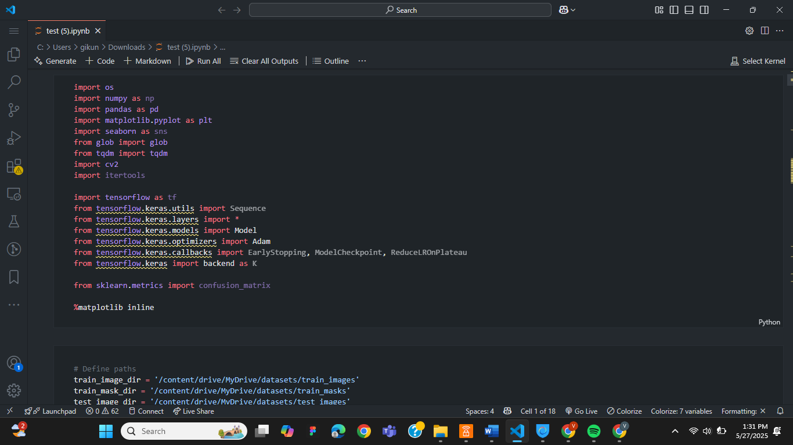

**Run the source code**

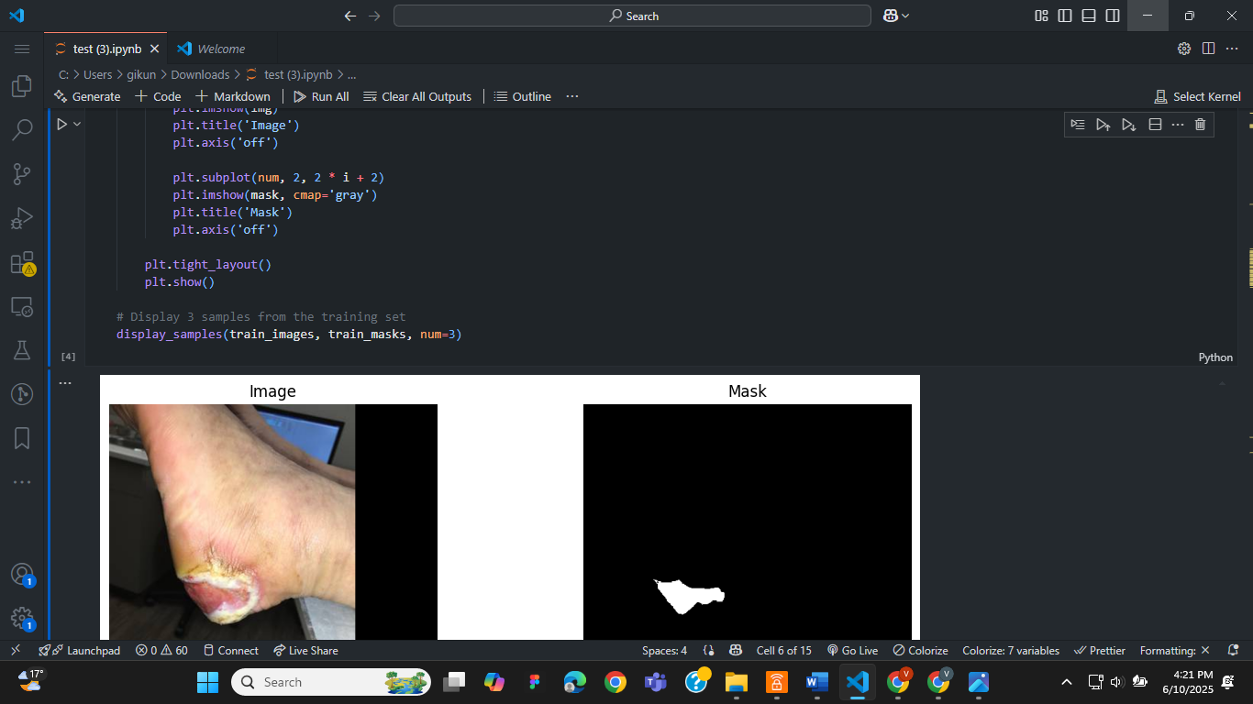

**Demonstration of images with corresponding masks**

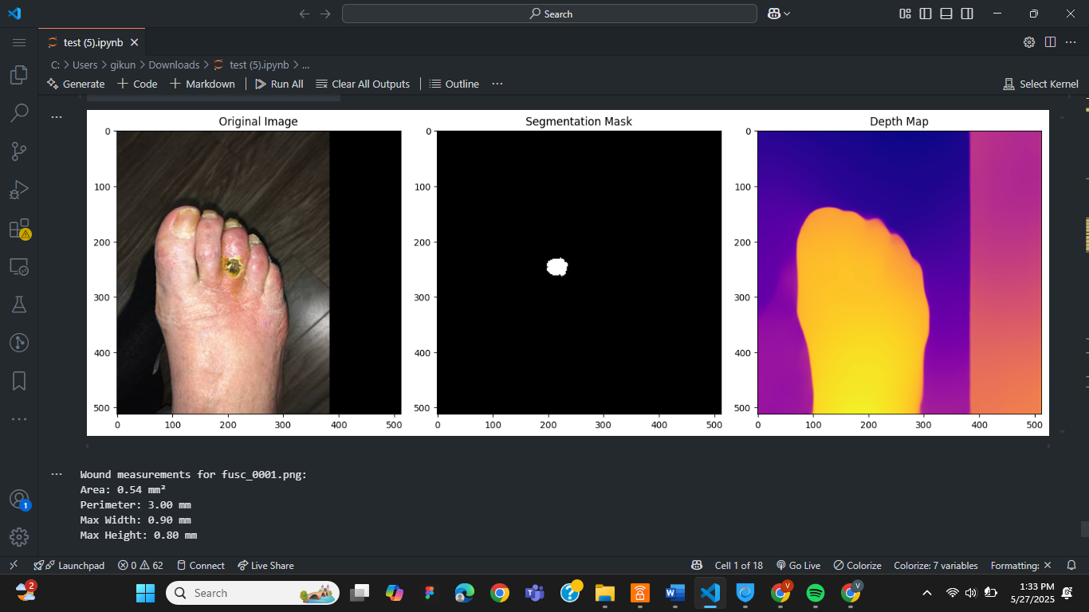

**Demonstration of the image processing and estimated size value**

## **5.7 FUTURE SCOPE**

Enhancing the model's accuracy and predictive capabilities in the future necessitates considering

extensive data for training. This approach is instrumental in enabling machines to effectively

recognize wounds and estimate the size.

## **5.8 CONCLUSION**

In this project, we have accomplished the creation of an application capable of recognize wounds and estimate the size. Our development involved the implementation of two distinct methods:

Wound identification and depth estimation to estimate the size of the wound, leveraging the CNN (Convolutional Neural Network) algorithm and Midas model. Following the training of the dataset, we conducted comprehensive testing by uploading images to evaluate the application's effectiveness in accurately detecting wounds.

# **CHAPTER 6: CONCLUSION AND FUTURE WORK**

## **6.1 Conclusion**

This project successfully implemented a robust pipeline for automated wound segmentation and depth estimation using a combination of Mask R-CNN for instance-level wound detection and MiDaS for monocular depth estimation. By leveraging tensorflow, Mask R-CNN and applying it to annotated wound images, the model was able to detect wound areas accurately and generate binary segmentation masks. These masks were then used to extract depth information, enabling quantitative assessments such as wound area and depth in real-world units.

The integration of computer vision and deep learning in this workflow provides an efficient, non-invasive method to support clinicians in monitoring wound progression and treatment efficacy. The pipeline is capable of handling varying wound shapes and backgrounds, and the use of data augmentation and preprocessing steps enhanced the model’s generalization capabilities.

## **6.2. Future Perspectives**

In advancing the field of AI-driven wound detection, segmentation, and depth estimation using Mask R-CNN and MiDaS, several future perspectives warrant attention. First and foremost, clinical validation is essential. Future efforts should prioritize validating the model with real-world clinical datasets that encompass a diverse range of patient demographics and wound types. This step is crucial to ensure the model's robustness and reliability in clinical settings.

Another promising direction involves 3D reconstruction. By integrating stereo vision or utilizing multiple view images, it would be possible to achieve 3D wound reconstruction, thereby enabling more accurate volume estimation. This advancement could significantly enhance the assessment of wound severity and treatment efficacy.

Model optimization is also a key area for future research. Employing techniques such as model pruning and quantization, or converting the model to formats like ONNX or TensorRT, could improve inference speed. This enhancement would facilitate the deployment of the model on edge devices, including mobile phones and embedded medical tools, making the technology more accessible for clinicians in various settings.

Additionally, incorporating temporal analysis could greatly benefit wound management. By utilizing temporal data to track wound healing over time, the model could support longitudinal studies and enable predictive modeling of healing trajectories. This capability would provide clinicians with valuable insights into the healing process and inform treatment decisions.

Furthermore, enhancing explainability and trust in AI models is vital for clinical adoption. Adding interpretability layers, such as Grad-CAM for Mask R-CNN, can increase trust and transparency for clinical users by highlighting the features that influence predictions. This transparency is essential for fostering confidence in AI-assisted decision-making.

User interface integration is another important consideration. Developing a user-friendly interface or mobile application that allows clinicians to upload images and receive instant segmentation and measurements would significantly enhance the practical utility of the model. Such tools could streamline workflows and improve patient care.

Finally, exploring multi-task learning presents an opportunity to further enhance diagnostic capabilities. By combining wound classification—such as differentiating between infected and non-infected wounds—with segmentation in a single multitask model, we could reduce the need for multiple models and improve overall efficiency in wound assessment.

# **REFERENCES:**

Chairat, S., Chaichulee, S., Dissaneewate, T., Wangkulangkul, P., & Kongpanichakul, L. (2023). AI-Assisted Assessment of Wound Tissue with Automatic Color and Measurement Calibration on Images Taken with a Smartphone. Healthcare, 11(2), 273. <https://doi.org/10.3390/healthcare11020273>

David Reifs, Lorena Casanova-Lozano, Ramon Reig-Bolaño, Sergi Grau-Carrion, .Clinical validation of computer vision and artificial intelligence algorithms for wound measurement and tissue classification in wound care, Informatics in Medicine Unlocked,Volume 37,2023,101185. https://doi.org/10.1016/j.imu.2023.101185.

Shah J. B. (2011). The history of wound care. The journal of the American College of Certified Wound Specialists, 3(3), 65–66. https://doi.org/10.1016/j.jcws.2012.04.002

Wang, A. Q., Karaman, B. K., Kim, H., Rosenthal, J., Saluja, R., Young, S. I., & Sabuncu, M. R. (2024). A Framework for Interpretability in Machine Learning for Medical Imaging. IEEE access : practical innovations, open solutions, 12, 53277–53292. https://doi.org/10.1109/access.2024.3387702

Li, M., Jiang, Y., Zhang, Y., & Zhu, H. (2023). Medical image analysis using deep learning algorithms. *Frontiers in public health*, *11*, 1273253. https://doi.org/10.3389/fpubh.2023.1273253

Patel, Y., Shah, T., Dhar, M.K. *et al.* Integrated image and location analysis for wound classification: a deep learning approach. *Sci Rep* 14, 7043 (2024). <https://doi.org/10.1038/s41598-024-56626-w>

Zhao, C., Guo, Y., Li, L., & Yang, M. (2024). Non-invasive techniques for wound assessment: A comprehensive review. *International wound journal*, *21*(11), e70109. <https://doi.org/10.1111/iwj.70109>

Rostami, B. et al. Multiclass wound image classifcation using an ensemble deep CNN-based classifer. Comput. Biol. Med. 134, 104536. https://doi.org/10.1016/j.compbiomed.2021.104536 (2021)

Wang, R., Lei, T., Cui, R., Zhang, B., Meng, H., Nandi, A.K.: Medical image segmentation using deep learning: A survey. IET Image Process. 16, 1243–1267 (2022). https://doi.org/10.1049/ipr2.12419

Huang, S. C., Chaudhari, A. S., Langlotz, C. P., Shah, N., Yeung, S., & Lungren, M. P. (2022). Developing medical imaging AI for emerging infectious diseases. Nature Communications, 13(1), 7060. https://doi.org/10.1038/s41467-022-34234-4